1.

A - Odd Sum.

B - First die is 1.

C - Sum is 7.

P(A) = 1/2

P(B) = 1/6

P(C) = 1/6

P(A,B) = 1/12

P(A,C) = 1/6

P(B,C) = 1/36

P(A)\*P(B) = 1/12

P(A)\*P(C) = 1/12

P(B)\*P(C) = 1/36

For any X,Y, X and Y are independent iff P(X,Y) = P(X)\*P(Y).

a) correct

b) incorrect

c) incorrect

2.

a)

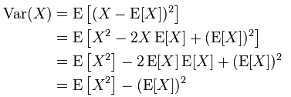

b)

3. P(allergic) = 0.001

P(Test = yes| allergic) = 0.9

P(Test = yes| not allergic) = 0.01

P(Test = yes) = P(allergic)\*P(Test = yes| allergic) + P( not allergic)\*P(Test = yes| not allergic) = 0.001\*0.9 + 0.999\*0.01 = 0.010899

By Bayes rule:

P(allergic| Test = yes) = P(Test = yes| allergic) \* P(allergic)/P(Test = yes) = 0.9\*0.001/0.010899 = 100/1211 = 0.0825763831544178364987613542526837324525185796862097.